LOYOLA COLLEGE (AUTONOMOUS), CHENNAI – 600 034
B.Com. DEGREE EXAMINATION – COMMERCE
FOURTH SEMESTER – APRIL 2006
LO 06

EL 4200 - BUSINESS COMMUNICATION
(Also equivalent to ENG 200)

Date & Time : 22-04-2006/1.00-4.00 P.M. Dept. No. Max. : 100 Marks

I. Write short notes on any five of the following in 100 words (5 x 5 = 25)
1. Agenda
2. Seminar and Panel discussion
3. Circular and notices
4. Memorandum
5. Dynamics of group discussion
6.7 Cs of Written Communication
7.Minutes of Meeting

II. Answer the following ( 3 x 10 = 30)
- You are the marketing manager of a computer company, and a local college has written to your department, asking if you would consider sponsoring their week- long drama festival to be held in the summer. Write a letter in 200 words to the principal of the college explaining that, while you sympathise with their aims and needs, your company has fixed a budget for sponsorship and no new ventures can be considered until next year.
Make up any necessary details.

2. Write a letter of application, enclosing your curriculum vitae in response to the following advertisement in 200 words

EXECUTIVES (Taxation)
Independent incharge Graduate in commerce with 5 years experience with a good knowledge of sales tax, excise duty, service tax, entry tax & other indirect taxes. Ability to understand and speak English & Hindi.
Box No: HB-1738
THE HINDU
Chennai – 600 002

3. Write a Memo in 150 words from the Managing Director to all staff, telling them that future working hours will be from 9.30 to 5.30, Monday to Friday, instead of 9-5. if anyone finds the new hours difficult, they are to let the Managing Director know within a week.

III. Answer the following (15 x 3 = 45)
- You recently attended a trade fair in another country. Your manager has now asked you to write a report about your visit to the fair. Write a report about your visit to the fair.
  - Write the report in 200 words describing your visit to the trade fair and including the following points:
  - Which other companies were represented?
  - How you spent your time
  - What information you obtained
  - Whether or not you recommend attending the fair next year (and why?)

- The chart below shows the percentages of a company’s turn over which were contributed by its main product areas in three successive years.
- Using the information in the chart, write a short report in 200 words comparing the contributions of the three products to turnover in the three years.
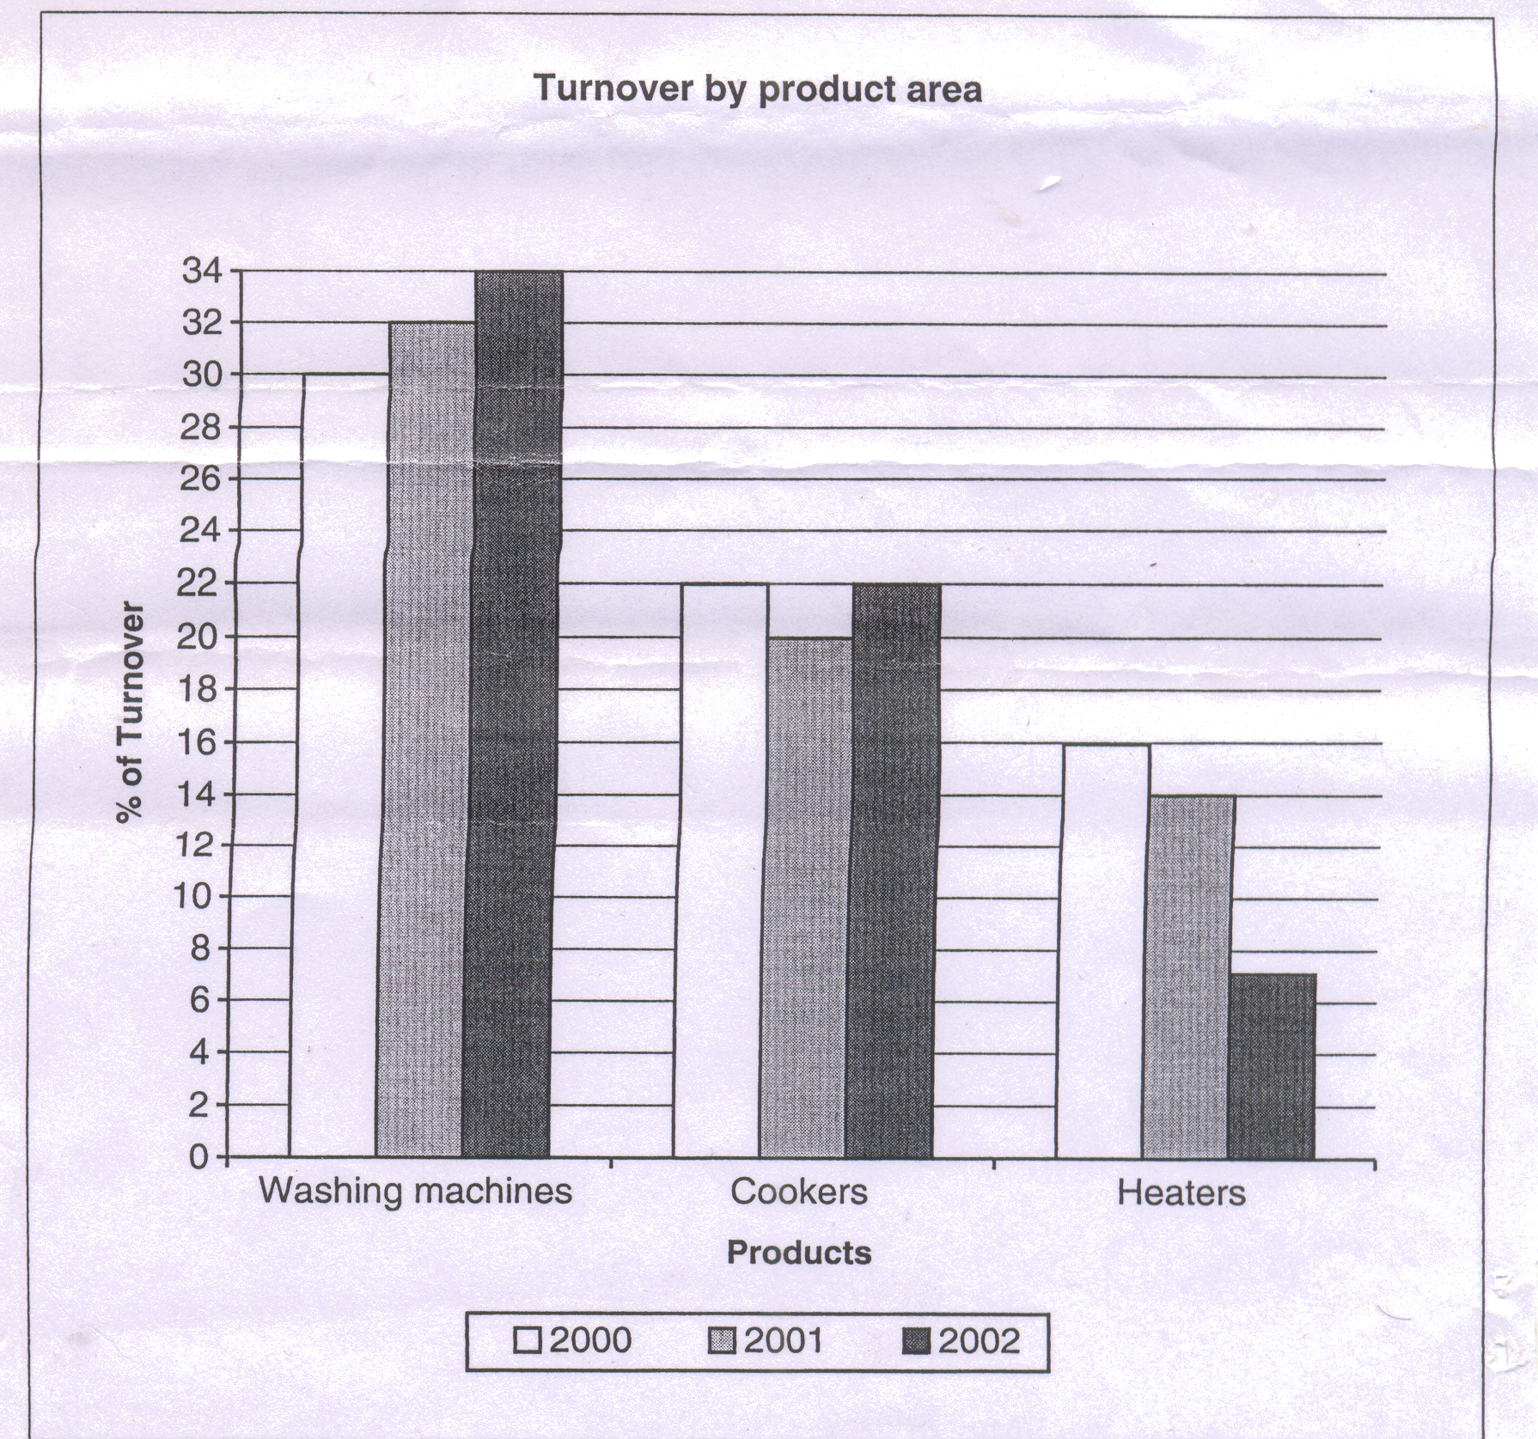

- Imagine that you are the secretary of the union of employees in a private company. Prepare the minutes of the meeting in 200 words based on the notice given below.
SOUTHERN LEATHER PRODUCTION LTD EMPLOYEES UNION
24, Old Palace Road, Pallavaram, Chennai – 78
Notice
Sir / Madam,
There will be a general body meeting of our union on 23 – 4 – 2005.
Venue : Silver star Auditorium.
Time : 5 pm
All are requested to attend the meeting without fail.
The following is the agenda:
- President’s remarks on the recent strike by the employees.
- Assessment of the recent strike and future plans.
- Legal remedy and financial help for those employees dismissed/suspended in the strike.
- Enhancement of monthly subscription from the employees.
- Any other, with the permission of chair
___________

